Alexandros Kokkalis, Elvar Halldor Hallfredsson, Lise Heggebakken

05/02/2020

## Introduction

This working document present a series of different assessments using the surplus production model in continous time (SPiCT; Pedersen and Berg (2017)) available as an R package (<https://github.com/DTUAqua/spict>).

## Read in the data

library(spict)  
  
## Read in the data  
dat <- readxl::read_xlsx("../data/GSS_indices270120_AK.xlsx")  
#plot(dat$year,dat$catchTOT,type = "l",ylim = c(0,max(na.omit(dat$catchTOT))))  
## Sum up the catches from each area to get the total catch  
dat$catchTOT <- dat$catch1and2 + dat$catch3 + dat$catch4  
#plot(dat$year,dat$catchTOT,type = "l", ylim = c(0,max(na.omit(dat$catchTOT))))  
## run retro or not   
runretro <- FALSE

## Scenario 1

Input data for Scenario 1

|  |  |  |  |
| --- | --- | --- | --- |
| Input data | Name | Range | Notes |
| Catch | Total catch | 1988-2018 |  |
| Biomass indices | Shrimp survey | 1984–2002 2005–2018 | Split in two periods |
|  |  |  | Default priors |

## Choose only the years where the survey was in October   
w <- !is.na(dat$northsea_month) & dat$northsea_month == 10  
## Choose only the years where the survey was in January or February   
v <- !is.na(dat$northsea_month) & dat$northsea_month %in% c(1, 2)  
  
  
## Make the input list  
inp_NS <- list(timeC = dat$year, ## Timing of catch  
 obsC = dat$catchTOT, ## Observed catches  
 timeI = list(dat$year[w] + dat$northsea_month[w] / 12, ## Timing of survey index  
 dat$year[v] + dat$northsea_month[v] / 12),  
 obsI = list(dat$northsea_SA[w], ## Observed indices  
 dat$northsea_SA[v]),  
 optimiser.control = list(iter.max = 1e5, ## Optimiser options   
 eval.max = 1e5), ## sometimes help converge  
 priors = list( ## List of priors (empty, i.e. default priors)  
 ## see possible priors with list.possible.priors()  
 ))  
## Check input time series, remove missing and zero observations  
inp_NS <- check.inp(inp_NS)

## Removing zero, negative, and NAs in C series

## Plot input data  
plotspict.data(inp_NS)

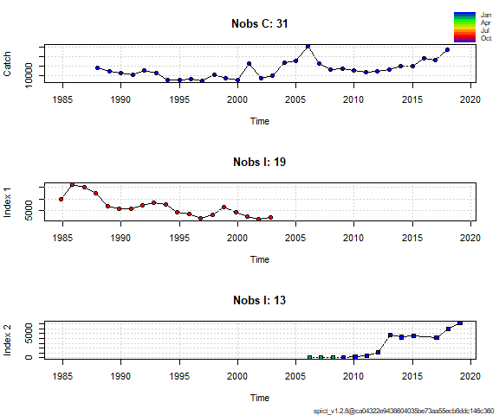

## Fit spict  
fit_NS <- fit.spict(inp_NS)  
  
## Summary of the fit - in the vignette there is a line-by-line description of that summary  
fit_NS

## Convergence: 0 MSG: relative convergence (4)  
## Objective function at optimum: 57.3810526  
## Euler time step (years): 1/16 or 0.0625  
## Nobs C: 31, Nobs I1: 19, Nobs I2: 13  
##   
## Priors  
## logn ~ dnorm[log(2), 2^2]  
## logalpha ~ dnorm[log(1), 2^2]  
## logbeta ~ dnorm[log(1), 2^2]  
##   
## Model parameter estimates w 95% CI   
## estimate cilow ciupp log.est   
## alpha1 2.390221e+00 0.6561160 8.707540e+00 0.8713858   
## alpha2 1.185998e+01 3.5324125 3.981958e+01 2.4731699   
## beta 9.416977e-01 0.3601728 2.462137e+00 -0.0600710   
## r 1.999363e-01 0.0614380 6.506482e-01 -1.6097566   
## rc 6.376559e-01 0.0245182 1.658384e+01 -0.4499565   
## rold 5.361626e-01 0.0090055 3.192149e+01 -0.6233178   
## m 2.551782e+04 1202.3903015 5.415541e+05 10.1471325   
## K 2.797479e+05 4660.6208760 1.679152e+07 12.5416442   
## q1 1.544270e-02 0.0000792 3.010343e+00 -4.1706220   
## q2 4.063500e-03 0.0000136 1.210055e+00 -5.5057111   
## n 6.270977e-01 0.0459170 8.564407e+00 -0.4666529   
## sdb 1.576217e-01 0.0512043 4.852053e-01 -1.8475574   
## sdf 1.625876e-01 0.0768551 3.439552e-01 -1.8165384   
## sdi1 3.767507e-01 0.2468519 5.750051e-01 -0.9761716   
## sdi2 1.869391e+00 1.2648928 2.762781e+00 0.6256125   
## sdc 1.531084e-01 0.0978477 2.395782e-01 -1.8766094   
##   
## Deterministic reference points (Drp)  
## estimate cilow ciupp log.est   
## Bmsyd 8.003635e+04 544.6157898 1.176209e+07 11.290236   
## Fmsyd 3.188279e-01 0.0122591 8.291918e+00 -1.143104   
## MSYd 2.551782e+04 1202.3903015 5.415541e+05 10.147132   
## Stochastic reference points (Srp)  
## estimate cilow ciupp log.est rel.diff.Drp   
## Bmsys 7.831263e+04 552.3440915 1.110335e+07 11.268464 -0.022010800   
## Fmsys 3.210608e-01 0.0122407 8.421108e+00 -1.136125 0.006954625   
## MSYs 2.514696e+04 1185.4484886 5.334435e+05 10.132492 -0.014747787   
##   
## States w 95% CI (inp$msytype: s)  
## estimate cilow ciupp log.est   
## B_2019.08 2.203227e+05 776.4156084 6.252077e+07 12.302849   
## F_2019.08 9.836480e-02 0.0003846 2.515559e+01 -2.319072   
## B_2019.08/Bmsy 2.813374e+00 0.4986872 1.587182e+01 1.034385   
## F_2019.08/Fmsy 3.063744e-01 0.0036177 2.594577e+01 -1.182947   
##   
## Predictions w 95% CI (inp$msytype: s)  
## prediction cilow ciupp log.est   
## B_2019.08 2.203227e+05 7.764156e+02 6.252077e+07 12.302849   
## F_2019.08 9.836480e-02 3.846000e-04 2.515559e+01 -2.319072   
## B_2019.08/Bmsy 2.813374e+00 4.986872e-01 1.587182e+01 1.034385   
## F_2019.08/Fmsy 3.063744e-01 3.617700e-03 2.594577e+01 -1.182947   
## Catch_2019.08 2.110211e+04 1.295520e+04 3.437222e+04 9.957128   
## E(B_inf) 1.727415e+05 NA NA 12.059552

## If the model converged, it reports convergence as 0  
## Continue with plotting and diagnostics only if convergence was reached  
converged <- fit_NS$opt$convergence == 0  
if (converged) {  
 ## Calculate the One Step Ahead (osa) residuals   
 fit_NS <- calc.osa.resid((fit_NS))  
   
 ## Make a plot showing relative F, relative B, Kobe plot catch   
 par(mfrow = c(2,2), ## 2x2 subplots  
 mar = c(4.1, 4.1, 0.5, 0.5)) ## Change default margins for the plots   
 plotspict.catch(fit_NS)  
 plotspict.ffmsy(fit_NS)  
 plotspict.bbmsy(fit_NS)  
 plotspict.fb(fit_NS)  
}

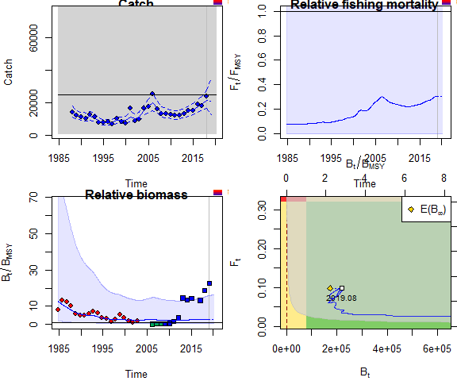

if (converged) {  
 plotspict.diagnostic(fit_NS)  
}

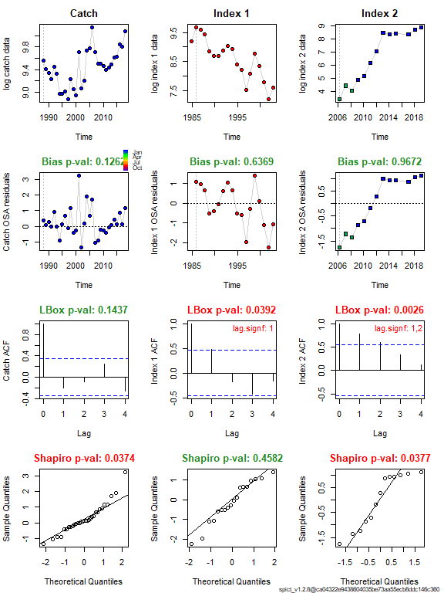

## If runretro is TRUE, run and plot the retrospective analysis  
 if (runretro & converged) {  
 fit_NS <- retro(fit_NS)  
 plotspict.retro(fit_NS)  
 }

## Scenario 2

Input data for Scenario 2

|  |  |  |  |
| --- | --- | --- | --- |
| Input data | Name | Range | Notes |
| Catch | Total catch | 1988-2018 |  |
| Biomass indices | Shrimp survey | 1984–2002 | Only october period |
| Biomass indices | Acoustic survey | 2009–2018 | StoX |
|  |  |  | Priors:logn=c(log(2),.5,1), |
|  |  |  | logbkfrac=c(log(.5),1,1) |

## Choose only the years where the survey was in October   
w <- !is.na(dat$northsea_month) & dat$northsea_month == 10  
## Choose only the years where the survey was in January or February   
##v <- !is.na(dat$northsea_month) & dat$northsea_month %in% c(1, 2)   
  
  
## Make the input list  
inp_NS <- list(timeC = dat$year, ## Timing of catch  
 obsC = dat$catchTOT, ## Observed catches  
 timeI = list(dat$year[w] + dat$northsea_month[w] / 12, ## Timing of survey index  
 dat$year+3.5/12),  
 obsI = list(dat$northsea_SA[w], ## Observed indices  
 dat$norwegian_sea_AC_stox),  
 optimiser.control = list(iter.max = 1e5, ## Optimiser options   
 eval.max = 1e5), ## sometimes help converge  
 priors = list( ## List of priors (empty, i.e. default priors)  
 logn=c(log(2),.5,1),  
 logbkfrac=c(log(.5),1,1)  
## see possible priors with list.possible.priors()  
 ))  
## Check input time series, remove missing and zero observations  
inp_NS <- check.inp(inp_NS)

## Removing zero, negative, and NAs in C series   
## Removing zero, negative, and NAs in I series 2

## Plot input data  
plotspict.data(inp_NS)

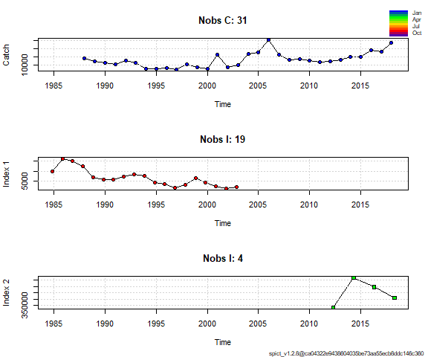

## Fit spict  
fit_NS <- fit.spict(inp_NS)  
  
## Summary of the fit - in the vignette there is a line-by-line description of that summary  
fit_NS

## Convergence: 0 MSG: relative convergence (4)  
## Objective function at optimum: 28.1080245  
## Euler time step (years): 1/16 or 0.0625  
## Nobs C: 31, Nobs I1: 19, Nobs I2: 4  
##   
## Priors  
## logn ~ dnorm[log(2), 0.5^2]  
## logbkfrac ~ dnorm[log(0.5), 1^2]  
## logalpha ~ dnorm[log(1), 2^2]  
## logbeta ~ dnorm[log(1), 2^2]  
##   
## Model parameter estimates w 95% CI   
## estimate cilow ciupp log.est   
## alpha1 2.770922e+00 8.323797e-01 9.224168e+00 1.0191802   
## alpha2 1.278742e+00 2.766823e-01 5.909958e+00 0.2458767   
## beta 1.089340e+00 4.172733e-01 2.843847e+00 0.0855720   
## r 1.985072e-01 4.893050e-02 8.053276e-01 -1.6169298   
## rc 2.671020e-01 4.460290e-02 1.599525e+00 -1.3201245   
## rold 4.081341e-01 1.521120e-02 1.095069e+01 -0.8961595   
## m 1.718695e+04 4.980648e+03 5.930782e+04 9.7519059   
## K 2.907047e+05 3.368074e+04 2.509125e+06 12.5800631   
## q1 1.899280e-02 1.075600e-03 3.353657e-01 -3.9636958   
## q2 2.452999e+00 1.275294e-01 4.718286e+01 0.8973112   
## n 1.486377e+00 6.057030e-01 3.647527e+00 0.3963419   
## sdb 1.456429e-01 5.222060e-02 4.061967e-01 -1.9265977   
## sdf 1.444124e-01 6.575660e-02 3.171538e-01 -1.9350819   
## sdi1 4.035651e-01 2.597342e-01 6.270441e-01 -0.9074175   
## sdi2 1.862396e-01 6.510980e-02 5.327184e-01 -1.6807210   
## sdc 1.573142e-01 1.038452e-01 2.383140e-01 -1.8495099   
##   
## Deterministic reference points (Drp)  
## estimate cilow ciupp log.est   
## Bmsyd 1.286920e+05 1.250275e+04 1.324640e+06 11.765178   
## Fmsyd 1.335510e-01 2.230150e-02 7.997627e-01 -2.013272   
## MSYd 1.718695e+04 4.980648e+03 5.930782e+04 9.751906   
## Stochastic reference points (Srp)  
## estimate cilow ciupp log.est rel.diff.Drp   
## Bmsys 1.230258e+05 1.232297e+04 1.228222e+06 11.720149 -0.04605724   
## Fmsys 1.309850e-01 2.072960e-02 8.276589e-01 -2.032673 -0.01959016   
## MSYs 1.610000e+04 4.684569e+03 5.533269e+04 9.686574 -0.06751300   
##   
## States w 95% CI (inp$msytype: s)  
## estimate cilow ciupp log.est   
## B_2018.27 1.866092e+05 9208.3482185 3.781676e+06 12.1367718   
## F_2018.27 1.106877e-01 0.0055164 2.220957e+00 -2.2010424   
## B_2018.27/Bmsy 1.516829e+00 0.5327076 4.319014e+00 0.4166223   
## F_2018.27/Fmsy 8.450413e-01 0.0977114 7.308206e+00 -0.1683698   
##   
## Predictions w 95% CI (inp$msytype: s)  
## prediction cilow ciupp log.est   
## B_2019.02 1.850808e+05 8.540752e+03 4.010759e+06 12.1285477   
## F_2019.02 1.134601e-01 5.558800e-03 2.315820e+00 -2.1763041   
## B_2019.02/Bmsy 1.504406e+00 4.948592e-01 4.573498e+00 0.4083982   
## F_2019.02/Fmsy 8.662069e-01 9.792560e-02 7.662085e+00 -0.1436315   
## Catch_2019.00 2.064753e+04 1.344021e+04 3.171978e+04 9.9353512   
## E(B_inf) 1.299476e+05 NA NA 11.7748867

## If the model converged, it reports convergence as 0  
## Continue with plotting and diagnostics only if convergence was reached  
converged <- fit_NS$opt$convergence == 0  
if (converged) {  
 ## Calculate the One Step Ahead (osa) residuals   
 fit_NS <- calc.osa.resid((fit_NS))  
   
 ## Make a plot showing relative F, relative B, Kobe plot catch   
 par(mfrow = c(2,2), ## 2x2 subplots  
 mar = c(4.1, 4.1, 0.5, 0.5)) ## Change default margins for the plots   
 plotspict.catch(fit_NS)  
 plotspict.ffmsy(fit_NS)  
 plotspict.bbmsy(fit_NS)  
 plotspict.fb(fit_NS)  
}

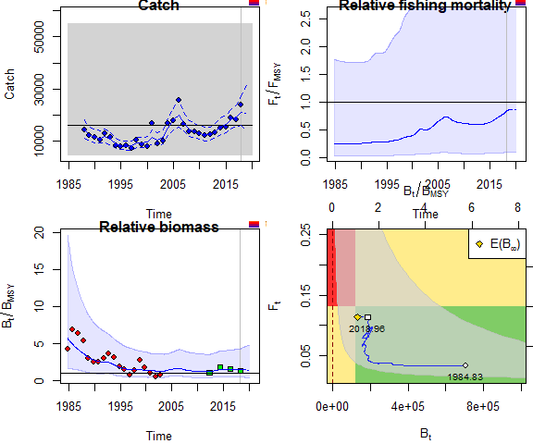

if (converged) {  
 plotspict.diagnostic(fit_NS)  
 plotspict.production(fit_NS)  
}

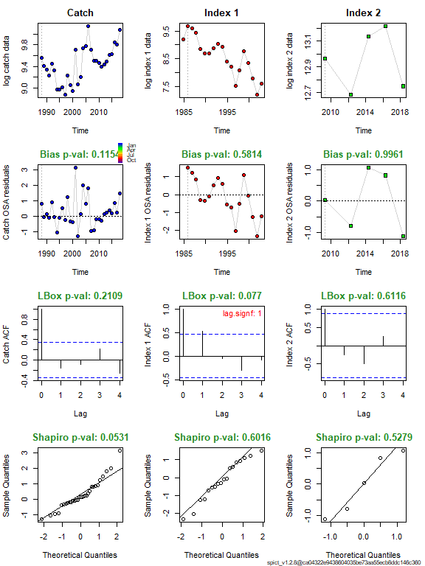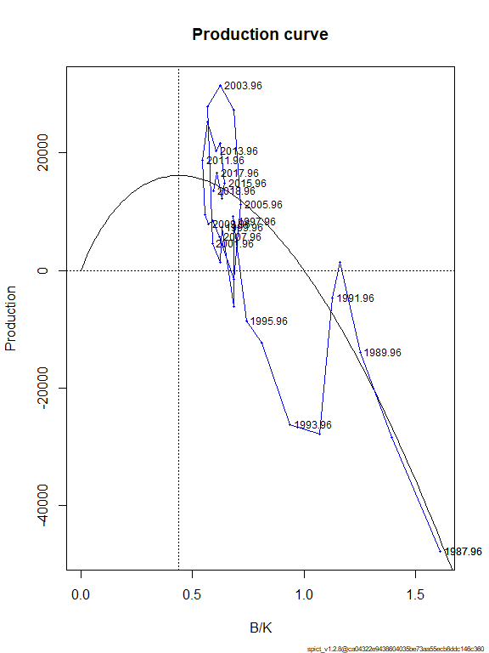

## If runretro is TRUE, run and plot the retrospective analysis  
 if (runretro & converged) {  
 fit_NS <- retro(fit_NS)  
 plotspict.retro(fit_NS)  
 }

## Scenario 3

Input data for Scenario 3

|  |  |  |  |
| --- | --- | --- | --- |
| Input data | Name | Range | Notes |
| Catch | Total catch | 1988-2018 |  |
| Biomass indices | Acoustic survey | 2009–2018 | StoX |
| Biomass indices | Acoustic survey | 1990-1993 | Monstad |
|  |  |  | Default priors |

## Choose only the years where the survey was in October   
w <- !is.na(dat$northsea_month) & dat$northsea_month == 10  
## Choose only the years where the survey was in January or February   
##v <- !is.na(dat$northsea_month) & dat$northsea_month %in% c(1, 2)  
  
  
## Make the input list  
inp_NS <- list(timeC = dat$year, ## Timing of catch  
 obsC = dat$catchTOT, ## Observed catches  
 timeI = list(dat$year+3.5/12,dat$year+3/12),## Timing of survey index  
 obsI = list(dat$norwegian_sea_AC_stox,dat$Norwegian_seaAC_Monstad), ## Observed indices  
 optimiser.control = list(iter.max = 1e3, ## Optimiser options   
 eval.max = 1e3), ## sometimes help converge  
 priors = list( ## List of priors (empty, i.e. default priors)  
 #logn=c(log(2),.5,1),  
 #logbkfrac=c(log(.5),1,1)  
## see possible priors with list.possible.priors()  
 ))  
## Check input time series, remove missing and zero observations  
inp_NS <- check.inp(inp_NS)

## Removing zero, negative, and NAs in C series   
## Removing zero, negative, and NAs in I series 1   
## Removing zero, negative, and NAs in I series 2

## Plot input data  
plotspict.data(inp_NS)

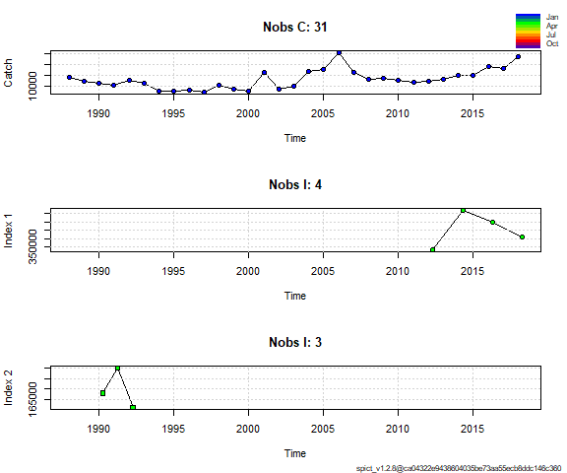

## Fit spict  
fit_NS <- fit.spict(inp_NS)  
  
## Summary of the fit - in the vignette there is a line-by-line description of that summary  
fit_NS

## Convergence: 0 MSG: relative convergence (4)  
## Objective function at optimum: 13.9012135  
## Euler time step (years): 1/16 or 0.0625  
## Nobs C: 31, Nobs I1: 4, Nobs I2: 3  
##   
## Priors  
## logn ~ dnorm[log(2), 2^2]  
## logalpha ~ dnorm[log(1), 2^2]  
## logbeta ~ dnorm[log(1), 2^2]  
##   
## Model parameter estimates w 95% CI   
## estimate cilow ciupp log.est   
## alpha1 4.422708e+00 5.081602e-01 3.849247e+01 1.4867521   
## alpha2 1.242919e+00 1.100758e-01 1.403441e+01 0.2174629   
## beta 9.256095e-01 3.283499e-01 2.609268e+00 -0.0773029   
## r 3.141806e-01 2.240040e-02 4.406601e+00 -1.1577872   
## rc 4.818807e-01 1.256344e-01 1.848291e+00 -0.7300587   
## rold 1.033568e+00 1.734000e-04 6.161500e+03 0.0330167   
## m 1.732498e+04 1.260624e+04 2.381004e+04 9.7599049   
## K 1.721747e+05 3.017732e+04 9.823320e+05 12.0562652   
## q1 6.175409e+00 8.913202e-01 4.278560e+01 1.8205751   
## q2 7.726347e+00 8.563336e-01 6.971166e+01 2.0446362   
## n 1.303977e+00 1.032494e-01 1.646843e+01 0.2654186   
## sdb 3.857370e-02 5.599600e-03 2.657207e-01 -3.2551845   
## sdf 1.719356e-01 8.116430e-02 3.642223e-01 -1.7606355   
## sdi1 1.706002e-01 7.481840e-02 3.890008e-01 -1.7684324   
## sdi2 4.794400e-02 1.296970e-02 1.772309e-01 -3.0377216   
## sdc 1.591452e-01 1.043248e-01 2.427725e-01 -1.8379384   
##   
## Deterministic reference points (Drp)  
## estimate cilow ciupp log.est   
## Bmsyd 7.190570e+04 1.595499e+04 3.240635e+05 11.183111   
## Fmsyd 2.409403e-01 6.281720e-02 9.241455e-01 -1.423206   
## MSYd 1.732498e+04 1.260624e+04 2.381004e+04 9.759905   
## Stochastic reference points (Srp)  
## estimate cilow ciupp log.est rel.diff.Drp   
## Bmsys 7.177423e+04 1.592011e+04 3.235869e+05 11.181281 -0.0018317803   
## Fmsys 2.408294e-01 6.272920e-02 9.245902e-01 -1.423666 -0.0004606897   
## MSYs 1.728533e+04 1.257666e+04 2.375690e+04 9.757613 -0.0022941808   
##   
## States w 95% CI (inp$msytype: s)  
## estimate cilow ciupp log.est   
## B_2018.25 7.217884e+04 1.027475e+04 5.070472e+05 11.1869022   
## F_2018.25 2.872639e-01 4.068240e-02 2.028409e+00 -1.2473540   
## B_2018.25/Bmsy 1.005637e+00 2.800870e-01 3.610687e+00 0.0056215   
## F_2018.25/Fmsy 1.192811e+00 3.154154e-01 4.510868e+00 0.1763125   
##   
## Predictions w 95% CI (inp$msytype: s)  
## prediction cilow ciupp log.est   
## B_2019.00 6.957439e+04 9.015330e+03 5.369294e+05 11.1501518   
## F_2019.00 2.988405e-01 4.061940e-02 2.198598e+00 -1.2078452   
## B_2019.00/Bmsy 9.693506e-01 2.561524e-01 3.668287e+00 -0.0311289   
## F_2019.00/Fmsy 1.240881e+00 3.164339e-01 4.866055e+00 0.2158214   
## Catch_2019.00 2.033666e+04 1.411775e+04 2.929503e+04 9.9201807   
## E(B_inf) 5.574812e+04 NA NA 10.9285990

## If the model converged, it reports convergence as 0  
## Continue with plotting and diagnostics only if convergence was reached  
converged <- fit_NS$opt$convergence == 0  
if (converged) {  
 ## Calculate the One Step Ahead (osa) residuals   
 fit_NS <- calc.osa.resid((fit_NS))  
   
 ## Make a plot showing relative F, relative B, Kobe plot catch   
 par(mfrow = c(2,2), ## 2x2 subplots  
 mar = c(4.1, 4.1, 0.5, 0.5)) ## Change default margins for the plots   
 plotspict.catch(fit_NS)  
 plotspict.ffmsy(fit_NS)  
 plotspict.bbmsy(fit_NS)  
 plotspict.fb(fit_NS)  
}

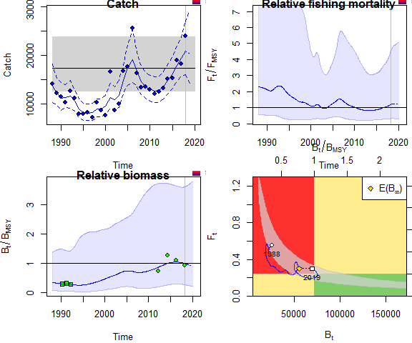

if (converged) {  
 plotspict.diagnostic(fit_NS)  
 plotspict.production(fit_NS)  
}

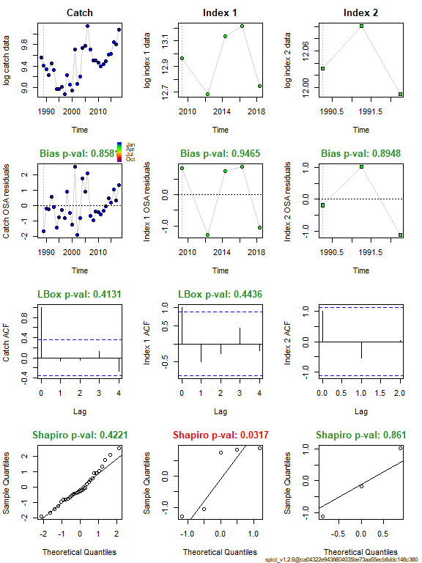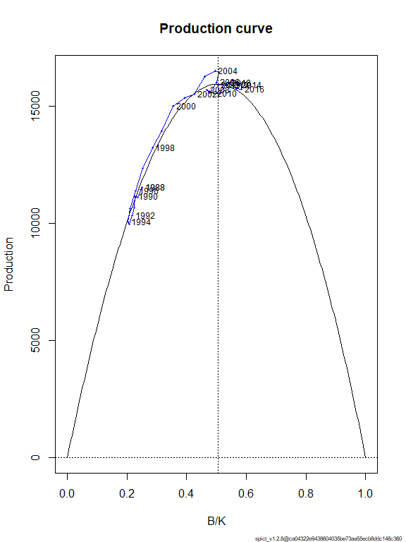

## If runretro is TRUE, run and plot the retrospective analysis  
 #runretro=TRUE  
if (runretro & converged) {  
 fit_NS <- retro(fit_NS)  
 plotspict.retro(fit_NS)  
 }

## Scenario 4

Input data for Scenario 4

|  |  |  |  |
| --- | --- | --- | --- |
| Input data | Name | Range | Notes |
| Catch | Total catch | 1988-2018 |  |
| Biomass indices | Acoustic survey | 2009–2018 | StoX |
| Biomass indices | Acoustic survey | 1990-1993 | Monstad |
|  |  |  | Default priors |

## Choose only the years where the survey was in October   
w <- !is.na(dat$northsea_month) & dat$northsea_month == 10  
w[1:4]<-FALSE  
## Choose only the years where the survey was in January or February   
##v <- !is.na(dat$northsea_month) & dat$northsea_month %in% c(1, 2)  
  
  
## Make the input list  
inp_NS <- list(timeC = dat$year, ## Timing of catch  
 obsC = dat$catchTOT, ## Observed catches  
 timeI = list(dat$year+3.5/12, dat$year+3/12),  
 obsI = list(dat$norwegian_sea_AC_stox,dat$Norwegian_seaAC_Monstad),  
 optimiser.control = list(iter.max = 1e3, ## Optimiser options   
 eval.max = 1e3), ## sometimes help converge  
 priors = list( ## List of priors (empty, i.e. default priors)  
 logn=c(log(2),.5,1)  
 #logbkfrac=c(log(.5),1,1)  
## see possible priors with list.possible.priors()  
 ))  
## Check input time series, remove missing and zero observations  
inp_NS <- check.inp(inp_NS)

## Removing zero, negative, and NAs in C series   
## Removing zero, negative, and NAs in I series 1   
## Removing zero, negative, and NAs in I series 2

## Plot input data  
plotspict.data(inp_NS)



## Fit spict  
fit_AC <- fit.spict(inp_NS)  
  
## Summary of the fit - in the vignette there is a line-by-line description of that summary  
fit_AC

## Convergence: 0 MSG: relative convergence (4)  
## Objective function at optimum: 12.5623155  
## Euler time step (years): 1/16 or 0.0625  
## Nobs C: 31, Nobs I1: 4, Nobs I2: 3  
##   
## Priors  
## logn ~ dnorm[log(2), 0.5^2]  
## logalpha ~ dnorm[log(1), 2^2]  
## logbeta ~ dnorm[log(1), 2^2]  
##   
## Model parameter estimates w 95% CI   
## estimate cilow ciupp log.est   
## alpha1 4.880942e+00 6.704762e-01 3.553235e+01 1.5853383   
## alpha2 1.361347e+00 1.526678e-01 1.213921e+01 0.3084749   
## beta 9.779617e-01 3.893076e-01 2.456692e+00 -0.0222848   
## r 4.295465e-01 1.191276e-01 1.548846e+00 -0.8450252   
## rc 4.557751e-01 1.585245e-01 1.310403e+00 -0.7857557   
## rold 4.854152e-01 9.565420e-02 2.463331e+00 -0.7227508   
## m 1.747139e+04 1.224026e+04 2.493813e+04 9.7683197   
## K 1.569284e+05 4.616570e+04 5.334378e+05 11.9635450   
## q1 5.208347e+00 1.259001e+00 2.154635e+01 1.6502626   
## q2 6.072720e+00 1.662306e+00 2.218481e+01 1.8038066   
## n 1.884905e+00 7.372030e-01 4.819390e+00 0.6338777   
## sdb 3.569060e-02 5.757100e-03 2.212596e-01 -3.3328684   
## sdf 1.653781e-01 8.419010e-02 3.248588e-01 -1.7995211   
## sdi1 1.742037e-01 8.066770e-02 3.761968e-01 -1.7475302   
## sdi2 4.858730e-02 1.526390e-02 1.546610e-01 -3.0243936   
## sdc 1.617334e-01 1.090203e-01 2.399341e-01 -1.8218059   
##   
## Deterministic reference points (Drp)  
## estimate cilow ciupp log.est   
## Bmsyd 7.666669e+04 2.227961e+04 2.638189e+05 11.247223   
## Fmsyd 2.278876e-01 7.926220e-02 6.552016e-01 -1.478903   
## MSYd 1.747139e+04 1.224026e+04 2.493813e+04 9.768320   
## Stochastic reference points (Srp)  
## estimate cilow ciupp log.est rel.diff.Drp   
## Bmsys 7.653202e+04 2.222670e+04 2.635186e+05 11.245464 -0.001759683   
## Fmsys 2.276104e-01 7.914150e-02 6.546063e-01 -1.480120 -0.001217736   
## MSYs 1.741945e+04 1.220335e+04 2.486508e+04 9.765342 -0.002981590   
##   
## States w 95% CI (inp$msytype: s)  
## estimate cilow ciupp log.est   
## B_2018.25 8.473260e+04 1.936805e+04 3.706938e+05 11.3472557   
## F_2018.25 2.434288e-01 5.694970e-02 1.040525e+00 -1.4129307   
## B_2018.25/Bmsy 1.107152e+00 5.706952e-01 2.147883e+00 0.1017913   
## F_2018.25/Fmsy 1.069498e+00 4.407644e-01 2.595094e+00 0.0671891   
##   
## Predictions w 95% CI (inp$msytype: s)  
## prediction cilow ciupp log.est   
## B_2019.00 8.220350e+04 1.764803e+04 3.828992e+05 11.3169532   
## F_2019.00 2.525728e-01 5.729300e-02 1.113453e+00 -1.3760556   
## B_2019.00/Bmsy 1.074106e+00 5.365548e-01 2.150207e+00 0.0714887   
## F_2019.00/Fmsy 1.109672e+00 4.415725e-01 2.788604e+00 0.1040641   
## Catch_2019.00 2.038817e+04 1.421398e+04 2.924426e+04 9.9227099   
## E(B_inf) 6.791407e+04 NA NA 11.1259985

## If the model converged, it reports convergence as 0  
## Continue with plotting and diagnostics only if convergence was reached  
converged <- fit_AC$opt$convergence == 0  
if (converged) {  
 ## Calculate the One Step Ahead (osa) residuals   
 fit_AC <- calc.osa.resid((fit_AC))  
   
 ## Make a plot showing relative F, relative B, Kobe plot catch   
 par(mfrow = c(2,2), ## 2x2 subplots  
 mar = c(4.1, 4.1, 0.5, 0.5)) ## Change default margins for the plots   
 plotspict.catch(fit_AC)  
 plotspict.ffmsy(fit_AC)  
 plotspict.bbmsy(fit_AC)  
 plotspict.fb(fit_AC)  
}

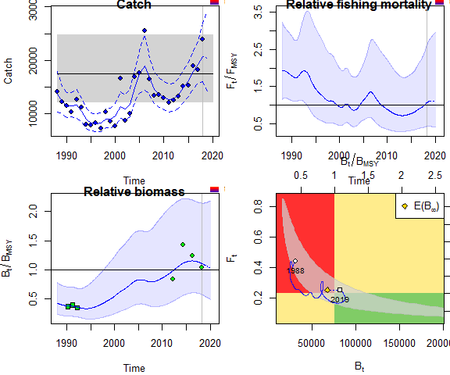

if (converged) {  
 plotspict.diagnostic(fit_AC)  
 plotspict.production(fit_AC)  
}

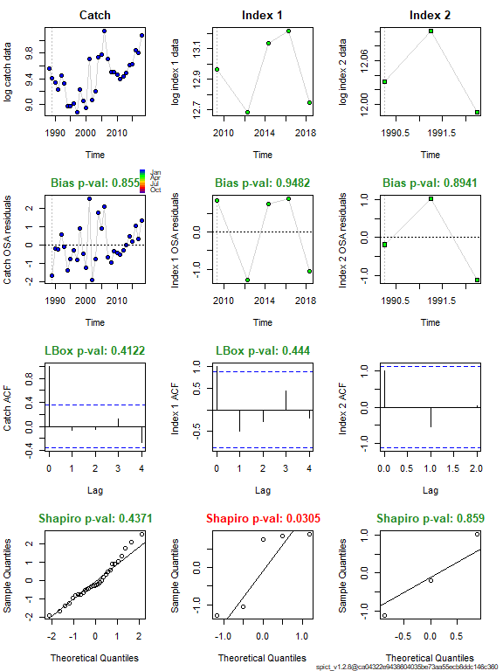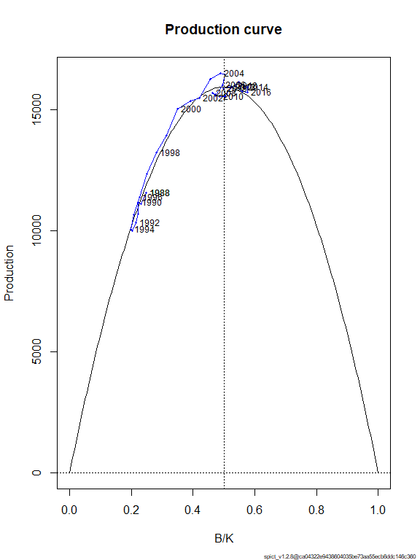

## If runretro is TRUE, run and plot the retrospective analysis  
 ## runretro=TRUE  
if (runretro & converged) {  
 fit_AC <- retro(fit_AC)  
 plotspict.retro(fit_AC)  
 }

##Scenario 5

Input data for Scenario 5

|  |  |  |  |
| --- | --- | --- | --- |
| Input data | Name | Range | Notes |
| Catch | Total catch | 1988-2018 |  |
| Biomass indices | Shrimp survey | 1988–2002 | Only october period |
| Biomass indices | Acoustic survey | 2009–2018 | StoX |
| Biomass indices | Acoustic survey | 1990-1993 | Monstad |
|  |  |  | Default priors |

## Choose only the years where the schrimp survey was in October   
w <- !is.na(dat$northsea_month) & dat$northsea_month == 10  
w[1:4]<-FALSE #remove years before 1988 in schrip survey  
## Choose only the years where the survey was in January or February   
v <- !is.na(dat$northsea_month) & dat$northsea_month %in% c(1)#c(1, 2)  
## Make the input list  
inp_NS <- list(timeC = dat$year, ## Timing of catch  
 obsC = dat$catchTOT, ## Observed catches dat$year[v] + dat$northsea_month[v] / 12  
 timeI = list(dat$year[w] + dat$northsea_month[w] / 12,dat$year+3.5/12, dat$year+3/12),  
 obsI = list(dat$northsea_SA[w],dat$norwegian_sea_AC_stox,dat$Norwegian_seaAC_Monstad),  
 optimiser.control = list(iter.max = 1e3, ## Optimiser options   
 eval.max = 1e3), ## sometimes help converge  
   
 priors = list( ## List of priors (empty, i.e. default priors)  
 logn=c(log(2),.5,1)  
 #logbkfrac=c(log(.5),1,1)  
## see possible priors with list.possible.priors()  
 ))  
## Check input time series, remove missing and zero observations  
inp_NS <- check.inp(inp_NS)

## Removing zero, negative, and NAs in C series   
## Removing zero, negative, and NAs in I series 2   
## Removing zero, negative, and NAs in I series 3

## Plot input data  
plotspict.data(inp_NS)

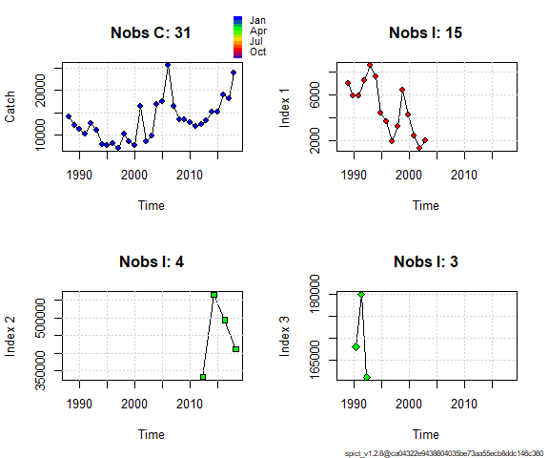

## Fit spict  
fit_NS <- fit.spict(inp_NS)  
  
## Summary of the fit - in the vignette there is a line-by-line description of that summary  
fit_NS

## Convergence: 0 MSG: relative convergence (4)  
## Objective function at optimum: 24.7243902  
## Euler time step (years): 1/16 or 0.0625  
## Nobs C: 31, Nobs I1: 15, Nobs I2: 4, Nobs I3: 3  
##   
## Priors  
## logn ~ dnorm[log(2), 0.5^2]  
## logalpha ~ dnorm[log(1), 2^2]  
## logbeta ~ dnorm[log(1), 2^2]  
##   
## Model parameter estimates w 95% CI   
## estimate cilow ciupp log.est   
## alpha1 3.742685e+00 1.0661283 1.313884e+01 1.3198033   
## alpha2 1.614257e+00 0.3475294 7.498141e+00 0.4788745   
## alpha3 4.688954e-01 0.0442392 4.969868e+00 -0.7573756   
## beta 1.171634e+00 0.4382486 3.132298e+00 0.1583990   
## r 3.233137e-01 0.0388112 2.693336e+00 -1.1291323   
## rc 3.132968e-01 0.0336047 2.920867e+00 -1.1606044   
## rold 3.038819e-01 0.0194018 4.759578e+00 -1.1911161   
## m 2.610602e+04 743.2713545 9.169252e+05 10.1699212   
## K 3.293055e+05 2358.0886384 4.598728e+07 12.7047410   
## q1 1.282910e-02 0.0000504 3.267047e+00 -4.3560400   
## q2 1.658810e+00 0.0049839 5.521055e+02 0.5061006   
## q3 4.114147e-01 0.0015121 1.119417e+02 -0.8881537   
## n 2.063945e+00 0.7012074 6.075049e+00 0.7246193   
## sdb 1.140260e-01 0.0376686 3.451663e-01 -2.1713288   
## sdf 1.403935e-01 0.0630275 3.127261e-01 -1.9633060   
## sdi1 4.267634e-01 0.2673152 6.813195e-01 -0.8515255   
## sdi2 1.840672e-01 0.0740638 4.574532e-01 -1.6924542   
## sdi3 5.346630e-02 0.0075874 3.767633e-01 -2.9287044   
## sdc 1.644898e-01 0.1114263 2.428231e-01 -1.8049070   
##   
## Deterministic reference points (Drp)  
## estimate cilow ciupp log.est   
## Bmsyd 1.666536e+05 1121.1652508 2.477193e+07 12.023673   
## Fmsyd 1.566484e-01 0.0168023 1.460434e+00 -1.853752   
## MSYd 2.610602e+04 743.2713545 9.169252e+05 10.169921   
## Stochastic reference points (Srp)  
## estimate cilow ciupp log.est rel.diff.Drp   
## Bmsys 1.625624e+05 1116.8161967 2.366239e+07 11.998817 -0.02516690   
## Fmsys 1.532150e-01 0.0157316 1.492207e+00 -1.875913 -0.02240894   
## MSYs 2.489296e+04 735.7212644 8.422475e+05 10.122340 -0.04873107   
##   
## States w 95% CI (inp$msytype: s)  
## estimate cilow ciupp log.est   
## B_2018.25 2.739175e+05 766.1777881 9.792871e+07 12.5205823   
## F_2018.25 7.466650e-02 0.0002109 2.643447e+01 -2.5947236   
## B_2018.25/Bmsy 1.684999e+00 0.5864277 4.841554e+00 0.5217649   
## F_2018.25/Fmsy 4.873315e-01 0.0053331 4.453133e+01 -0.7188106   
##   
## Predictions w 95% CI (inp$msytype: s)  
## prediction cilow ciupp log.est   
## B_2019.00 2.722341e+05 7.104022e+02 1.043231e+08 12.5144175   
## F_2019.00 7.673720e-02 2.125000e-04 2.770646e+01 -2.5673689   
## B_2019.00/Bmsy 1.674643e+00 5.451508e-01 5.144320e+00 0.5156002   
## F_2019.00/Fmsy 5.008463e-01 5.357500e-03 4.682168e+01 -0.6914559   
## Catch_2019.00 2.064245e+04 1.373083e+04 3.103315e+04 9.9351051   
## E(B_inf) 2.344834e+05 NA NA 12.3651400

## If the model converged, it reports convergence as 0  
## Continue with plotting and diagnostics only if convergence was reached  
converged <- fit_NS$opt$convergence == 0  
if (converged) {  
 ## Calculate the One Step Ahead (osa) residuals   
 fit_NS <- calc.osa.resid((fit_NS))  
   
 ## Make a plot showing relative F, relative B, Kobe plot catch   
 par(mfrow = c(2,2), ## 2x2 subplots  
 mar = c(4.1, 4.1, 0.5, 0.5)) ## Change default margins for the plots   
 plotspict.catch(fit_NS)  
 plotspict.ffmsy(fit_NS)  
 plotspict.bbmsy(fit_NS)  
 plotspict.fb(fit_NS)  
}

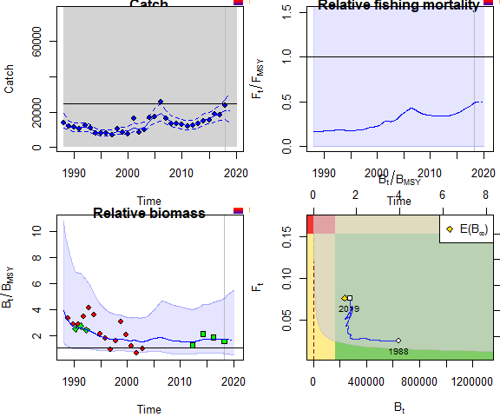

if (converged) {  
 plotspict.diagnostic(fit_NS)  
 plotspict.production(fit_NS)  
}

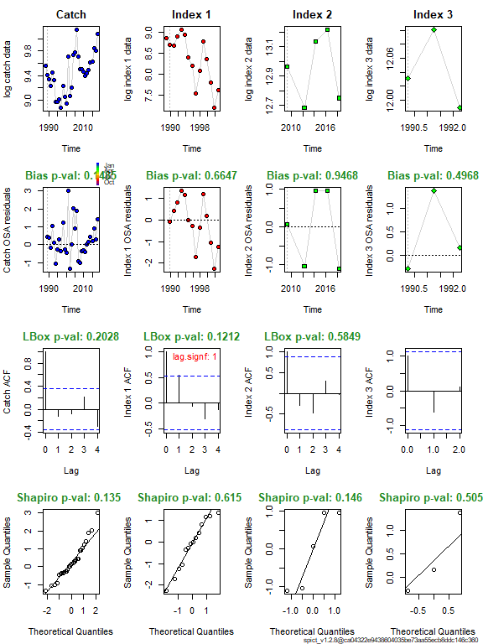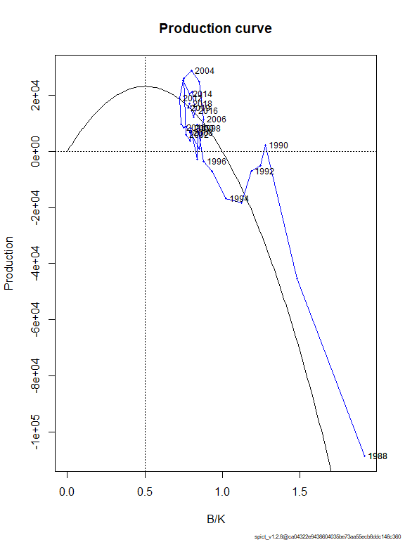

## If runretro is TRUE, run and plot the retrospective analysis  
 #runretro=TRUE  
if (runretro & converged) {  
 fit_NS <- retro(fit_NS)  
 plotspict.retro(fit_NS)  
 }

### Biomass comparsin scenario 4 and 5

bAC <- get.par(parname = "logBBmsy",fit_AC, exp = TRUE)  
time <- as.numeric(rownames(bAC))  
bNS <- get.par(parname = "logBBmsy",fit_NS, exp = TRUE)  
BmsyAC<- get.par(parname = "Bmsy",fit_AC)  
  
  
meanAC <- mean(bAC[,2][time > 2005 & time < 2019])  
meanNS <- mean(bNS[,2][time > 2005 & time < 2019])  
ylim <- c(0.6, 1.4)  
par(mfrow =c(1,1))  
plot(time, bNS[,2] / meanNS,type="l", ylim = ylim, xlim=c(2005,2018),ylab = "Bioamass")  
lines(time, bAC[,2] / meanAC,col="red")  
#points(dat$year, dat$norwegian_sea_AC_stox / mean(dat$norwegian_sea_AC_stox, na.rm = TRUE, col="blue"),pch =3 )  
points(dat$year, dat$norwegian_sea_AC_stox / mean(dat$norwegian_sea_AC_stox ,na.rm = TRUE), col="red",pch=16)  
#lines(dat$year, dat$norwegian_sea_AC_stox / mean(dat$norwegian_sea_AC_stox ,na.rm = TRUE)), col="red")  
legend("bottomright",c("NS", "AC"), col = 1:2, seg.len = 4, lty = 1)

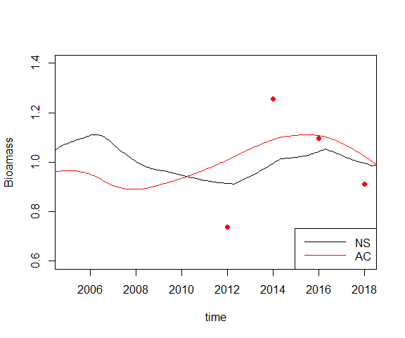

#plot(time, bAC[,2] / meanAC,xlim=c(2005,2018),type = "l",ylim =c(0.6,1.4), ylab = "Biomass AC")  
  
idx2 <- c(which(floor(time) == 2017)[1], which(floor(time) == 2018)[1])  
#time[idx2]  
idx3 <- c(which(floor(time) == 2014)[1], which(floor(time) == 2015)[1], which(floor(time) == 2016)[1])  
#time[idx3]  
ratio2_3AC <- mean(bAC[idx2,2]) / mean(bAC[idx3,2])  
ratio2_3AC

## [1] 0.9528668

ratio2_3ACexp <- mean(BmsyAC[2]*exp(bAC[idx2,2])) / mean(BmsyAC[2]*exp(bAC[idx3,2]))  
ratio2_3ACexp

## [1] 0.9476579

## Referneces

Pedersen, Martin W., and Casper W. Berg. 2017. “A stochastic surplus production model in continuous time.” *Fish and Fisheries* 18 (2): 226–43. <https://doi.org/10.1111/faf.12174>.